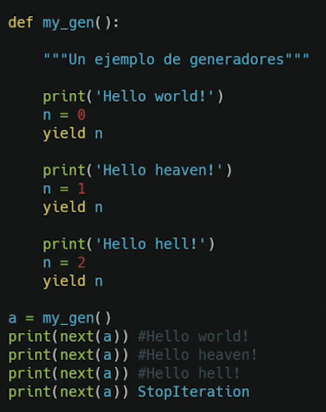

Imprime Hello world

yield n returna 0

llama a next, y continua donde se dio el yield 0

Imprime Hello heaven

Yield n return 1

Llama a next y continua donde fue yield 1

Imprime Hello hell

Return 2

Llama a nex y continua donde fue yield 2 (no hay nada)

Se levanta error “StopIteration”

Version mas compacta de Fibonacci

from time import sleep

def **fibonacci_gen**():

a, b = 0, 1

while True:

yield a

a, b = b, a+b

if __name__ == "__main__":

fibonacci = **fibonacci_gen**()

for element in fibonacci:

print(element)

sleep(1)

from time import sleep

def fibonacci_gen(max_counter:int):

**a**, b = 0, 1

**while** **a** <= max_counter:

yield **a**

**a**, b = b, **a**+b

**if** __name__ == "__main__":

**for** **element** **in** fibonacci_gen(39):

print(**element**)

sleep(0.3)

[Ver más](https://platzi.com/comentario/2760727/)



**William Leonardo Torres Toloza**

[Hace 4 meses](https://platzi.com/comentario/2760727/)

2

import time

def fibo_gen(stop: int):

n1 = 0

n2 = 1

counter = 0

while True:

if counter == 0:

counter += 1

yield n1

elif counter == 1:

counter += 1

yield n2

else:

aux = n1 + n2

if not stop or aux <= stop:

n1, n2 = n2, aux

counter += 1

yield aux

else:

break

if __name__ == '__main__':

fibonacci = fibo_gen(5)

for element in fibonacci:

print(element)

time.sleep(1)